**Inventory Management Using IBM Cognos Analytics**

**A PROJECT REPORT**

***Submitted by***

**ANANYA SINGH**

**19BCE10342**

***in partial fulfillment for the award of the degree of***

**BACHELOR OF TECHNOLOGY**

*in*

**PROGRAM OF STUDY**

**SCHOOL OF COMPUTING SCIENCE AND ENGINEERING**

**VIT BHOPAL UNIVERSITY**

**KOTHRIKALAN, SEHORE**

**MADHYA PRADESH – 466114**

**JAN 2022**

**LIST OF FIGURES**

|  |  |  |
| --- | --- | --- |
| **S.No** | **Topic** | **Page No.** |
| **1.** | **Year Wise Price Using Line Graph** | **10** |
| **2.** | **Year Wise Stock Using Line Graph** | **11** |
| **3.** | **Top 10 Sales By Year Using Line Graph** | **11** |
| **4.** | **Top 10 Revenue By Year Using Line Graph** | **12** |
| **5.** | **Monthly Stock Using Heat Map** | **12** |
| **6.** | **Monthly Sales Using Tree Map** | **13** |
| **7.** | **Monthly Revenue By Pie Chart** | **13** |
| **8.** | **Summary Card of Total Revenue, Sales, Stock and Price** | **14** |
| **9.** | **Dashboard Creation** | **14** |

|  |  |  |
| --- | --- | --- |
| **S.No** | **Title** | **Page No** |
|  | **List of figures** |  |
| **1.** | **INTRODUCTION**  **1.1 Overview**  **1.2 Purpose** | **4-5** |
| **2.** | **LITERATURE SURVEY**  **2.1 Existing Problem**  **2.2 Proposed Solution** | **6** |
| **3.** | **THEORETICAL ANALYSIS**  **3.1 Block Diagram** | **7** |
| **4.** | **EXPERIMENTAL INVESTIGATION** | **8** |
| **5.** | **FLOWCHART** | **9** |
| **6.** | **RESULT** | **10-14** |
| **7.** | **ADVANTAGES AND DISADVANTAGES** | **15-16** |
| **8.** | **APPLICATIONS** | **17** |
| **9.** | **CONCLUSION** | **18** |
| **10.** | **FUTURE SCOPE** | **18** |

**INTRODUCTION**

**OVERVIEW**

Inventory is the goods or materials a business intends to sell to customers for profit. Inventory management, a critical element of the supply chain, is the tracking of inventory from manufacturers to warehouses and from these facilities to a point of sale. The goal of inventory management is to have the right products in the right place at the right time. This requires inventory visibility — knowing when to order, how much to order and where to store stock.

This project is based on an understanding of the HR analytics dataset. It has 938

data points (rows) and 4 features (columns). Features are Date, Sales, Stocks, Price.

Inventory can be a company’s most important asset. Inventory management is where all the elements of the supply chain converge. Too little inventory when and where it's needed can create unhappy customers. But a large inventory has its own liabilities — the cost to store and insure it, and the risk of spoilage, theft and damage. Companies with complex supply chains and manufacturing processes must find the right balance between having too much inventory on hand or not enough.

Multichannel order fulfillment operations typically have inventory spread across many places throughout the supply chain. Inventory visibility is knowing what inventory you have and where it’s located. Businesses need an accurate view of inventory to guarantee fulfillment of customer orders, reduce shipment turnaround times, and minimize stock outs, oversells and markdowns.

4.

**PURPOSE**

• To create data visualization charts like those mentioned below:

Line Graph analysis date, sales, stock, price and revenue

Year Wise Price Using Line Graph

Year Wise Stock Using Line Graph

Top 10 Sales by Year Using Line Graph

Top 10 Revenue by Year Using Line Graph

Monthly Stock Using Heat Map

Monthly Sales Using Tree Map

Monthly Revenue by Pie Chart

Summary Card of Total Revenue, Sales, Stock and Price

Dashboard Creation

5.

**LITERATURE SURVEY**

**EXISTING PROBLEM**

• If we are finding unusual patterns within our data analysis or our statistical significance

is not strong enough, we might not have enough data to make valid conclusions

• Without doing data analysis, we won’t get the opportunity to evaluate the data before

making actionable plans

• Data is meaningless without context and without context, we cannot turn data into

information

• Information is useless without being able to apply to something.

**PROPOSED SOLUTION**

• To create various data visualizations using IBM Cognos

• To make a dashboard using IBM Cognos

• Making dashboards can revolutionize both our success and enjoyment in running our business.

6

**THEORETICAL ANALYSIS**

**BLOCK DIAGRAM**

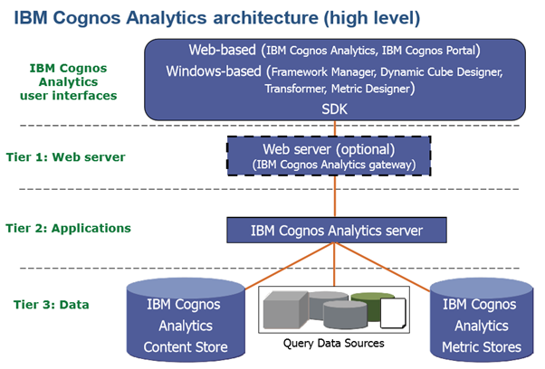

**7**

**EXPERIMENTAL INVESTIGATION**

**DATA PREPARATION**

**Monthly Calculation to prepare the data by using the formula monthly(data_).**

**Then renamed the data as year and changed the properties.**

**After uploading the data set renamed Venda to sales and converted the sales type to Measure from Attribute.**

**Then renamed Estoque to stocks and converted the stocks type to Measure from Attribute.**

**Then renamed Preco to price and converted the price type to Measure from Attribute.**

**Created Revenue sales*price**

**8**

**FLOWCHART**

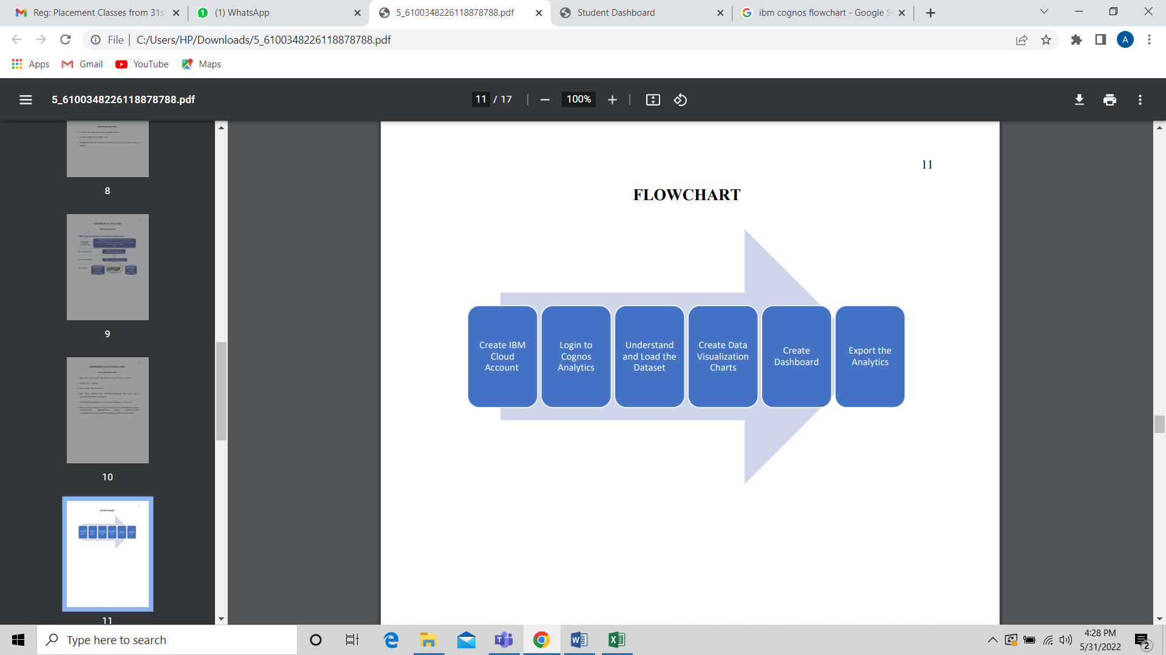

**9**

**RESULT**

1. **Year wise price using Line graph**

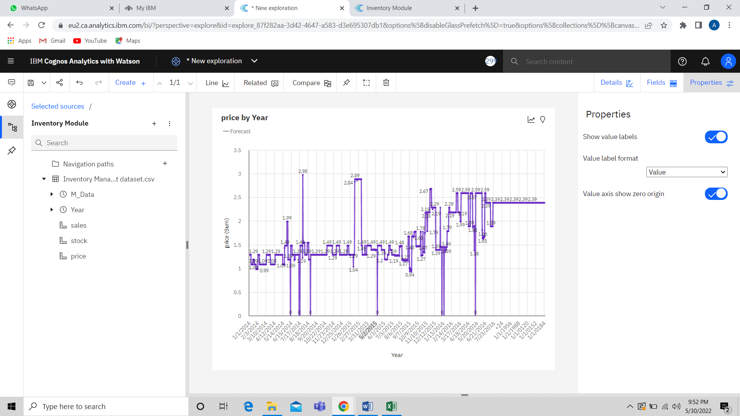

**10**

1. **Year wise stock using line graph**

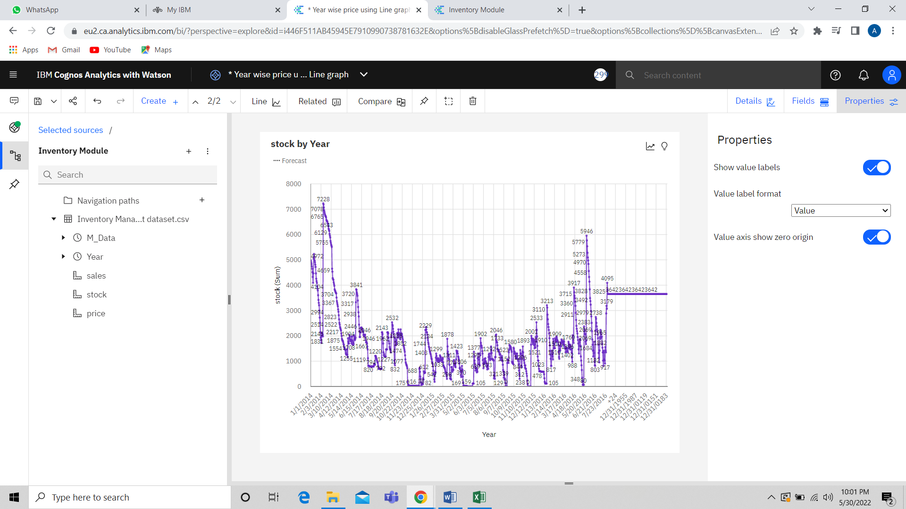

1. **Top 10 Sales by Year using Line graph**

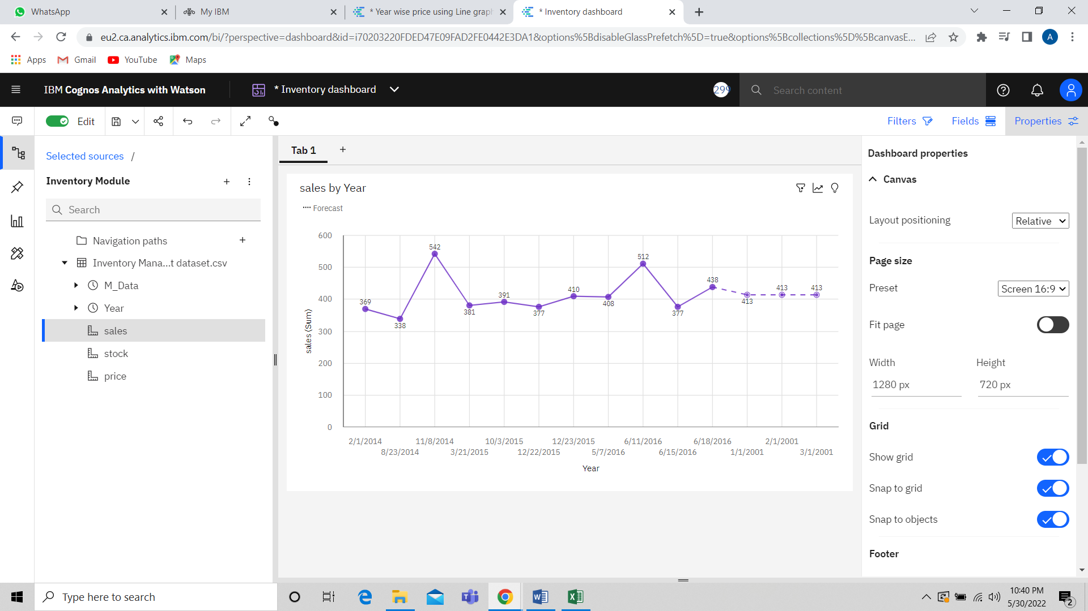

**11**

1. **Top 10 Revenue by using Line Graph**

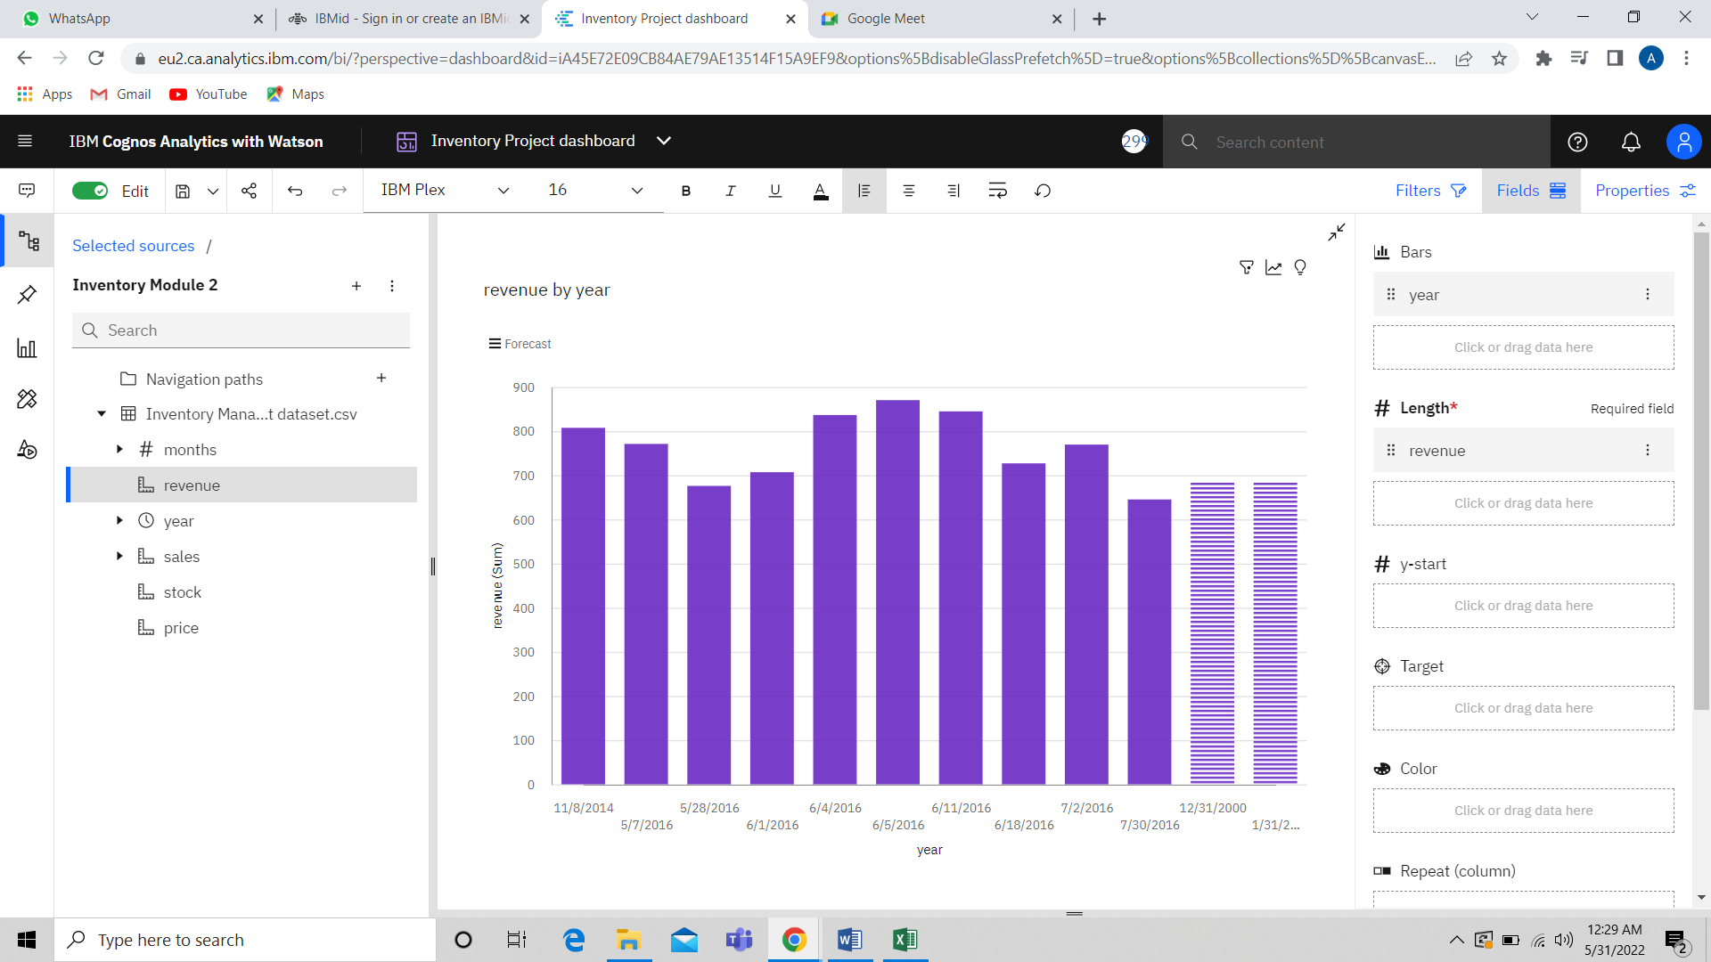

1. **Monthly Stock Using Heap Map:**

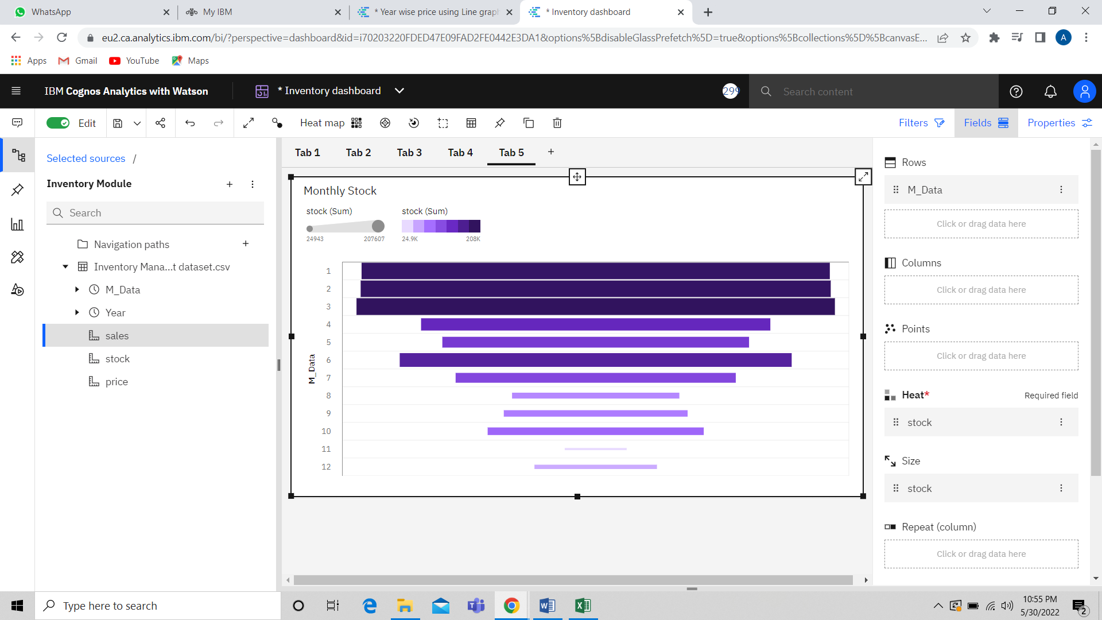

**12**

1. **Monthly Sales Using Tree Map**

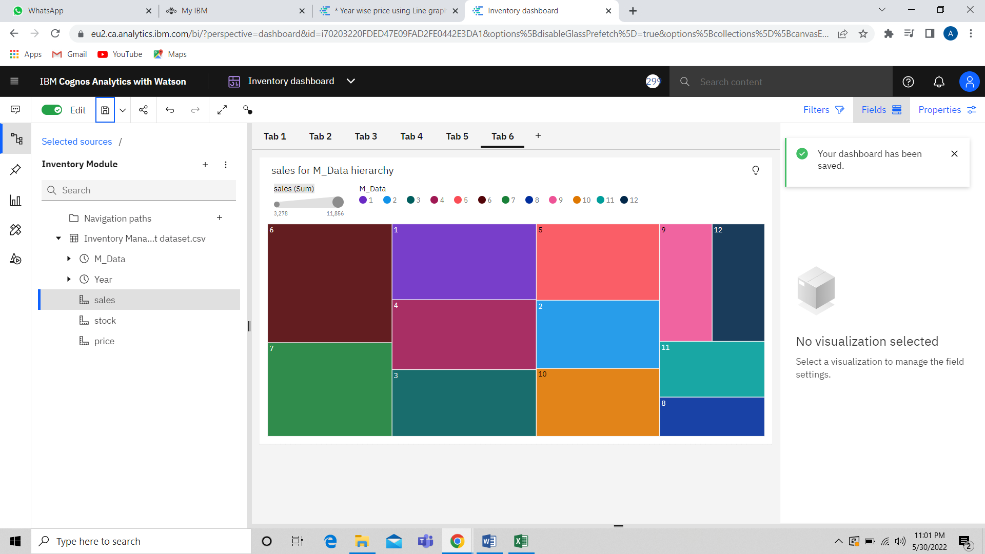

1. **Monthly Revenue by Pie Chart:**

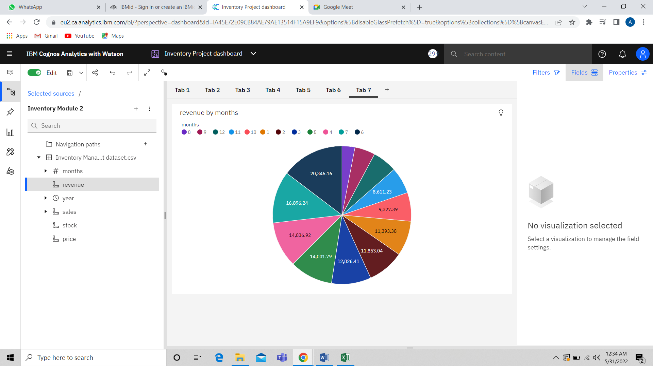

**13**

1. **Summary Cards of Total Revenue, Stocks, Sales, Price:**

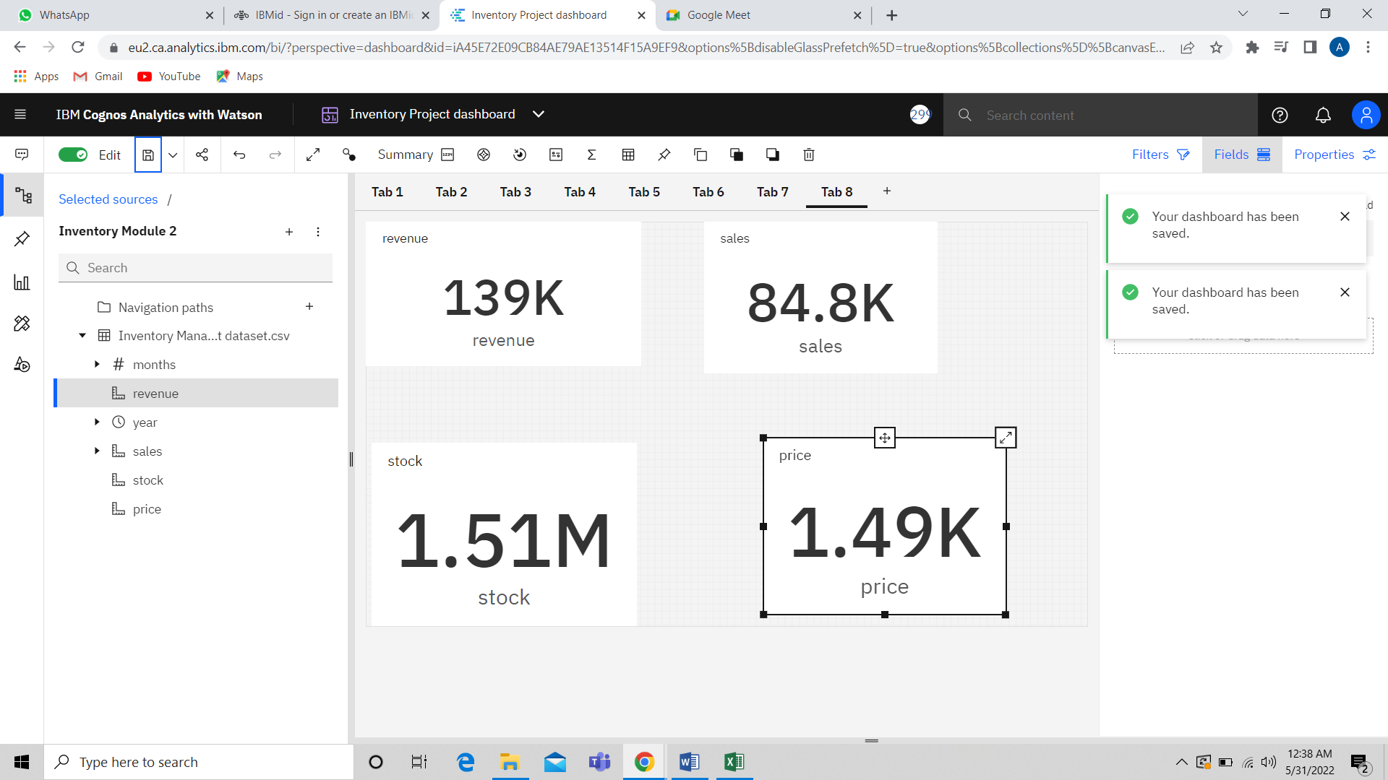

1. **Dashboard Creation:**

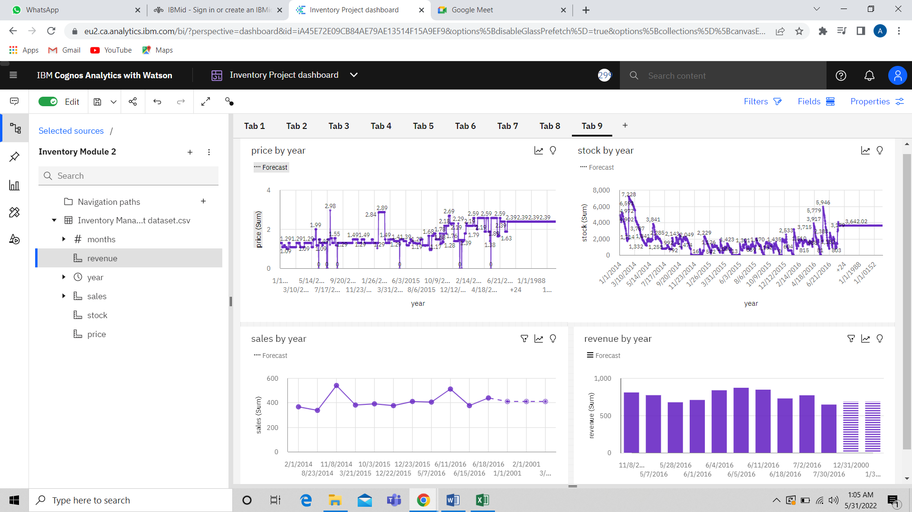

**14**

**ADVANTAGES AND DISADVANTAGES OF CREATING**

**DASHBOARD**

**ADVANTAGES**

**•** Enhanced Visibility: Dashboards provide greater visibility with information available whenever it is required to ensure businesses are better placed to respond to changing market conditions

• Timesaving Efficiency: With dashboards, we are no longer wasting valuable time

generating reports from multiple systems. Instead, data is drawn from a source and displayed as an easy to interpret visual overview

• Better Forecasting: With greater insight into the data, future demand can be more accurately predicted using historic information. Businesses can be more effectively planned for demand fluctuations, setting measurable goals and deliverables for greater success.

• Better Decision Making: Whether you’re providing reporting and analysis for the entire organization or functional areas of the business, a dashboard allows companies to analyze key data quickly and meticulously. Visualized interactivity serves to deliver

overwhelming amounts of data in a way that is easy to understand. With the ability to

easily identify what the data really means; better decisions can be made relevant to the

business.

**DISADVANTAGES**

• Flashy or cluttered design, with users attempting to incorporate too much information without understanding constraints or considering their specific needs from the range of different measurable detailed data analysis provides.

15

• The technology used in the development of dashboards differs from other software

solutions already employed in organizations and can be initially difficult to understand.

The business has no predetermined rules and hierarchies for how dashboard metrics are used. This means each employee can use the metrics in different ways, resulting in a diverse set of data being reported.

**16**

**APPLICATIONS**

• If you manage complex campaigns, you usually end up having several analytics

solutions for each platform and needing to consult them separately, which hinders the overall view. Instead, the dashboard displays data from different sources, like web analytics solutions, social media metrics. This way, makes it much easier to compare them and see how they develop.

• A good dashboard clearly shows you a number of key metrics so you don't need to be an analytics expert to understand them. If you want to look further into a particular dataset, you always have the option of employing more specific tools.

• If you synchronize your dashboard automatically in the cloud, you can create different users so that your entire team can access the same information from anywhere. It's even possible to project the dashboard onto a screen in your office so that the whole team can see what is going on in real time.

• Having a centralized dashboard will save you a lot of time. Instead of collecting data from different sources and making charts on your own, dashboards do all this work for you. You just need to invest some time at the beginning to set up the metrics and decide how to present them. From that point on, the reports are created automatically.

17

**CONCLUSION**

From this project, we have successfully:

• Created multiple analysis charts / graphs

• Used the analyzed chart creation of dashboard

• Saved and visualized the final dashboard in the IBM Cognos Analytics

**FUTURE SCOPE**

Various other charts can be prepared like:

• Monthly income vs Number of Companies Worked

• Years in Current Role vs Total Working Years

• Monthly Income vs Years at Company.

18